**SAMPLE LESSON LEVEL 17**

**Student Questions and Responses**

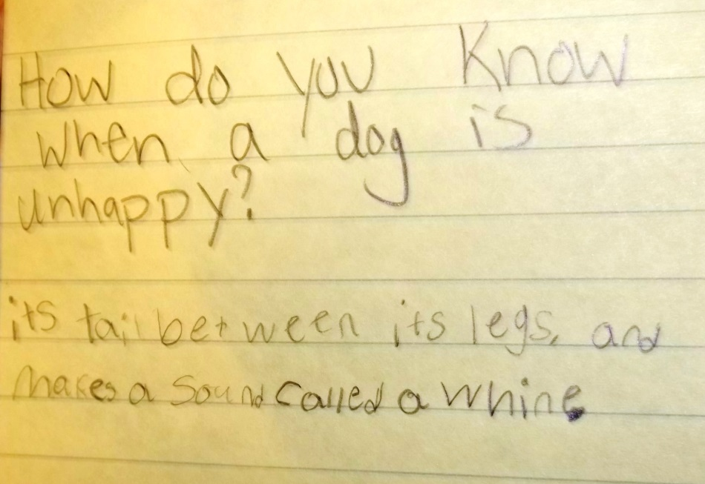 Pages 8-9

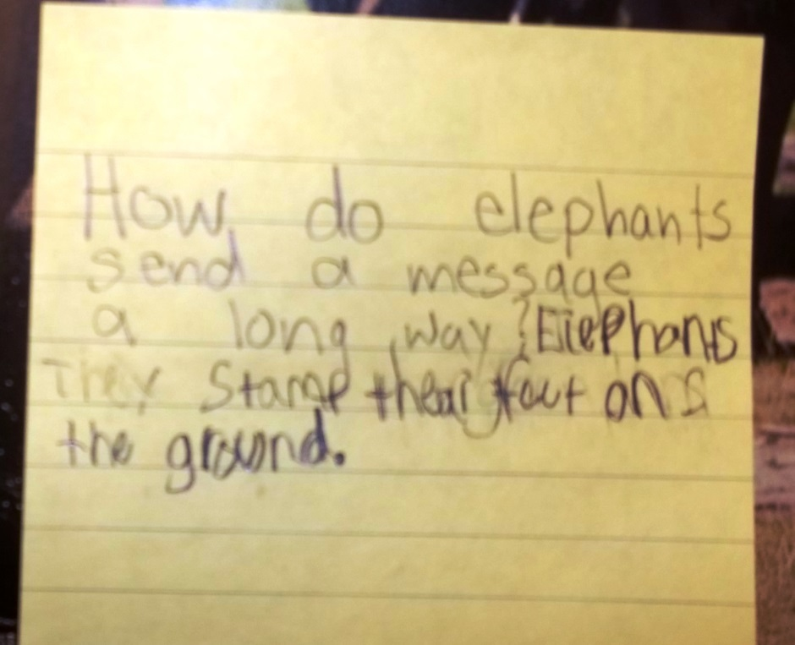 Pages 4-5

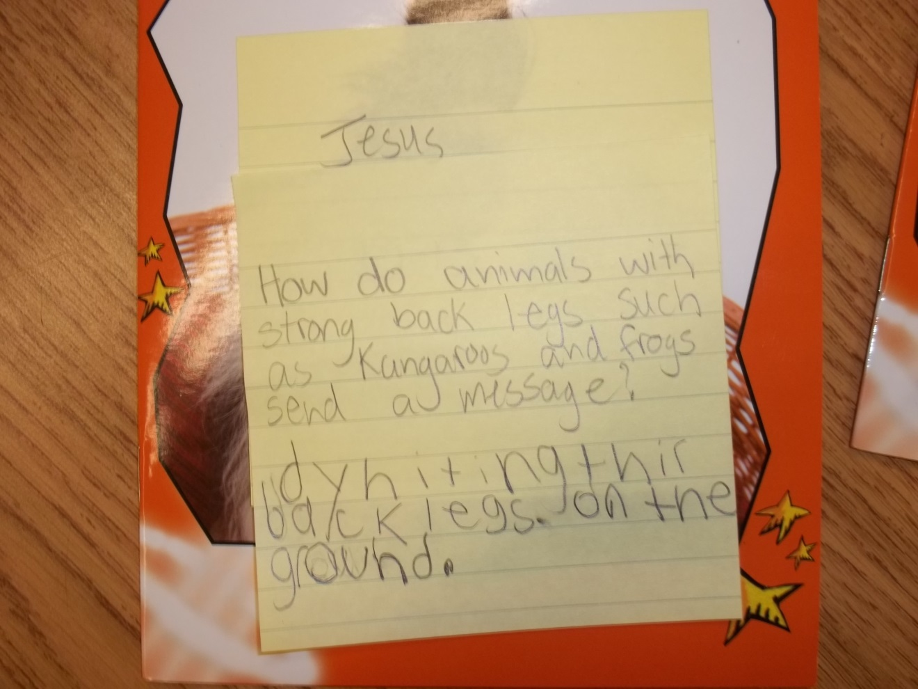

Pages 10-11

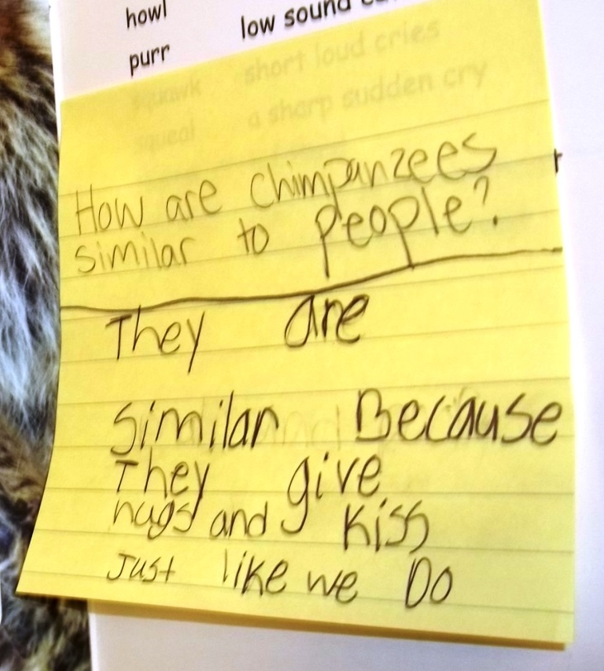 Page 16