Tom is Brave
by Beverly Randell, Illustrated by Ernest Papps
Rigby PM Readers
Text of New Book
Sample Lesson Level 5 (57 words)

Pages | Text | Illustration
1-2 | Tom went to the store  for Mom. | [Tom in front of the store.]
3-4 | Tom! Tom!  Look where you are going!  Look where you are going! | [Tom looking backwards at a passing motorcycle; uneven sidewalk is ahead of him.]
5-6 | 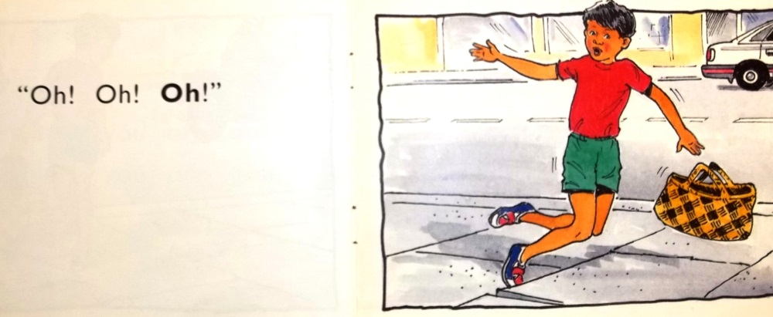
7-8 | Tom cried and cried. | [Tom sitting on sidewalk with pained look on face, holding his bloody knee and crying]
9- 10 | Tom went home.  “Look, Mom!  I am bleeding!”  “Oh, Tom!” said Mom. | [Tom walking up to a house with woman standing in doorway; his bloody knee is visible.]
11-12 | “Here you are,” said Mom.  “You are brave.” | [Mom and Tom in bathroom; she is fixing up his knee. Water, bandages, scissors are visible and it looks like she is putting a band aids on his knee.]
13-14 | Tom went into the store.  “Look!” he said. | [Tom in the store, showing the band aids on both knees to the clerk.]
15-16 | “Look at me!” | [Tom showing knees to a woman and two children who have come into the store}

